**SE4050 – Deep Learning**

**Lab – 05**

**ID NUMBER: IT21067242**

**Task 1: Understanding Basic RNN Architecture**

**Objective:** Implement a simple RNN to predict the next value in a small sequence of numbers.

**Task:**

* Modify the units parameter in the SimpleRNN layer to see how the number of hidden units affects the model's ability to learn the sequence.

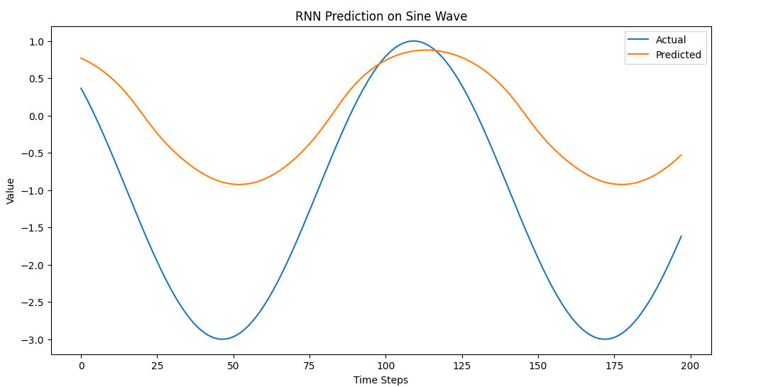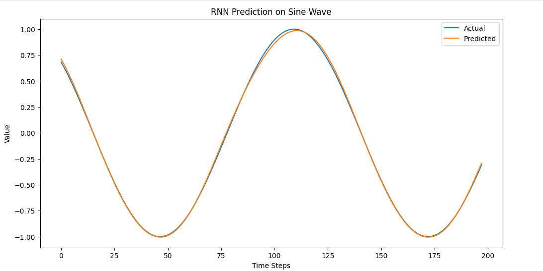

Unit = 05

Unit = 15

Unit = 50

**Fewer Units (05)**: The model may not have enough capacity to learn the sequence properly, which could result in underfitting.

**More Units (50)**: The model might have a higher capacity to learn the sequence, potentially improving accuracy. However, too many units might lead to overfitting or increased training time without significant improvement

* Adjust the epochs and batch_size during training to optimize the model's learning process and performance.

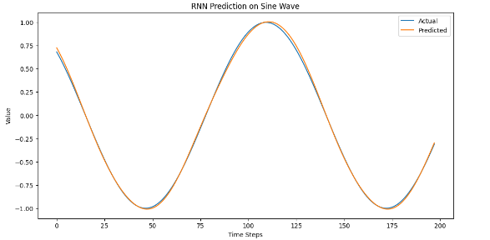**epochs=30, batch_size=32**

Moderate Epochs with a Moderate Batch Size

* This provides a balanced approach, good for comparing with other configurations.

**epochs=10, batch_size=64**

Fewer Epochs with a Larger Batch Size

* This might lead to faster training but might not capture all patterns in the data.

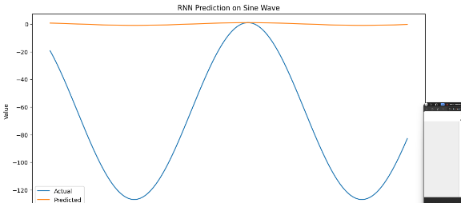**epochs=20, batch_size=32**

More Epochs with a Smaller Batch Size

* This could potentially improve accuracy, but be cautious of overfitting.

**Task 2: Implementing LSTM for Time-Series Forecasting**

**Objective:** Implement an LSTM model to predict stock prices using historical data.

Task:

1. Answer the following questions. (You can type answers in a text cell)
   1. What is the purpose of normalizing the 'Close' prices before feeding them into the LSTM model?
   2. What is the purpose of the Dropout layer in the LSTM model?
   3. In the plot showing actual vs predicted stock prices, what does it indicate if the predicted line closely follows the actual line?
2. **Purpose of Normalizing the 'Close' Prices:**

* Normalizing the 'Close' prices before feeding them into the LSTM model is essential to ensure that the data is scaled to a range (typically 0 to 1). This process improves the training process by speeding up convergence, reducing the risk of getting stuck in local minima, and helping the model learn more effectively since LSTM networks are sensitive to the scale of input data.

1. **Purpose of the Dropout Layer:**

* The Dropout layer in the LSTM model is used to prevent overfitting by randomly setting a fraction of the input units to 0 at each update during training. This forces the model to learn more robust features and not rely too heavily on any single input, leading to better generalization on unseen data.

1. **Interpretation of Predicted vs. Actual Stock Prices:**

* If the predicted line closely follows the actual line in the plot, it indicates that the model has successfully learned the underlying patterns in the data and can accurately predict stock prices. A close match suggests that the model has good predictive performance, while significant deviations could indicate the need for further tuning of the model's parameters or architecture.